SPECIALS SCHEDULE 2023-2024
Miss Jones’s Kindergarten Class

Monday | Tuesday | Wednesday | Thursday | Friday
Spanish  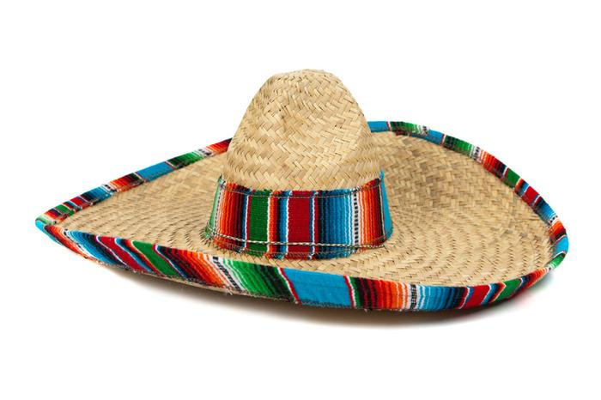 | Library  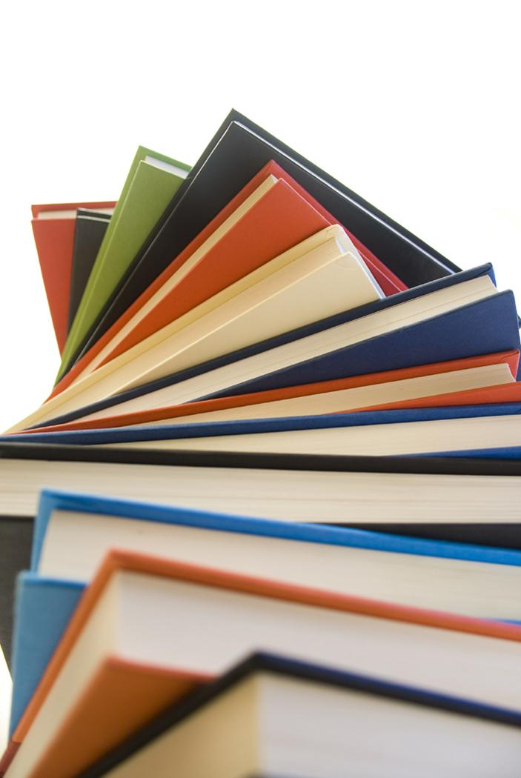  P.E.  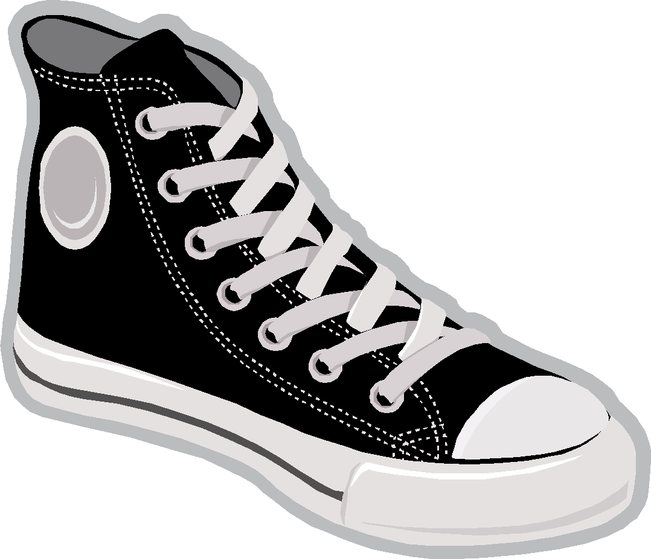  *Remember to wear or bring sneakers on Gym days | Computers  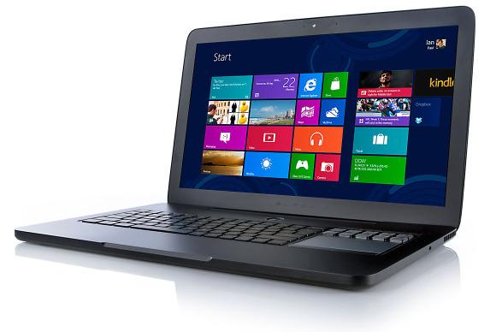 | P.E.  *Remember to wear or bring sneakers on Gym days  Music   | Art  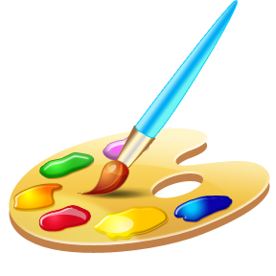  *Send in a smock  for Art.

